Chinook DB SQL Ex.2

Part 1

Q.1 What is the title of the album with AlbumId 67?

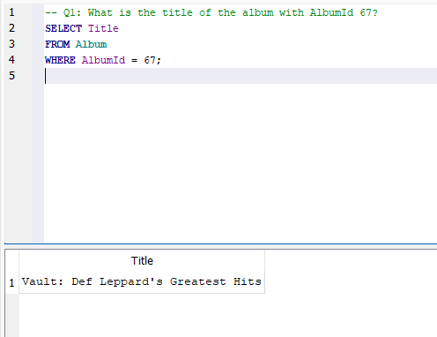

Q.2 Find the name and length (in seconds) of all tracks that have length between 50 and 70 seconds.

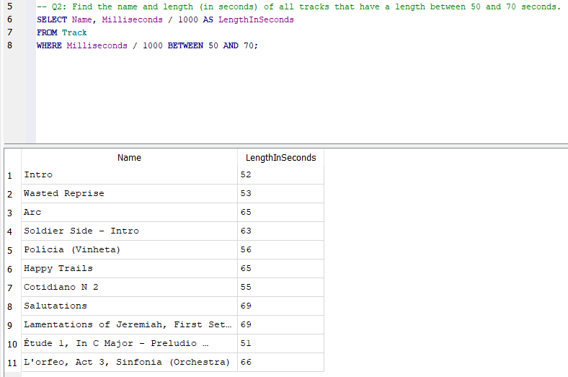

Q.3 List all the albums by artists with the word ‘black’ in their name.

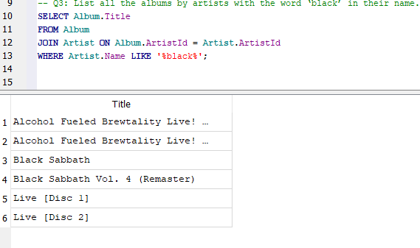

Q.4 Provide a query showing a unique/distinct list of billing countries from the Invoice table

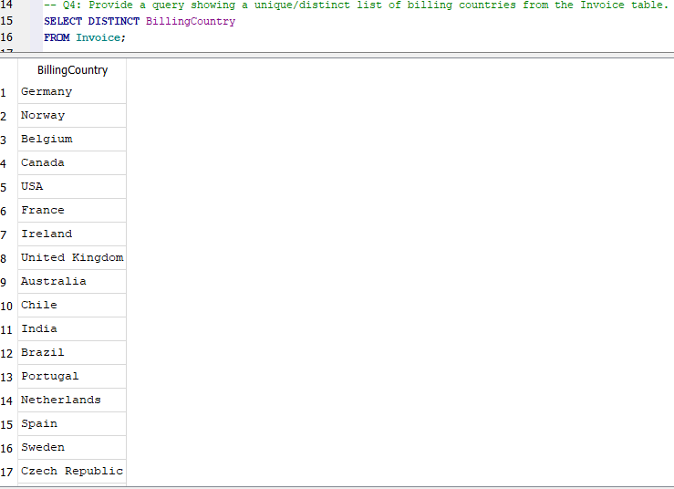

Q.5 Display the city with highest sum total invoice.

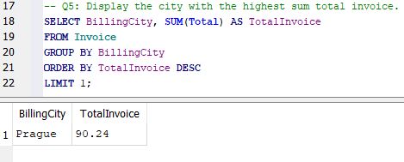

Q.6 Produce a table that lists each country and the number of customers in that country. (You only need to include countries that have customers) in descending order. (Highest count at the top)

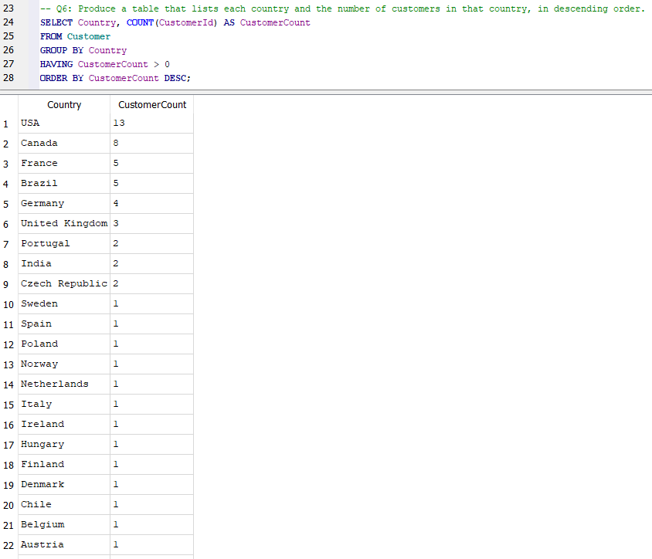

Q.7 Find the top five customers in terms of sales i.e. find the five customers whose total combined invoice amounts are the highest. Give their name, CustomerId and total invoice amount. Use join

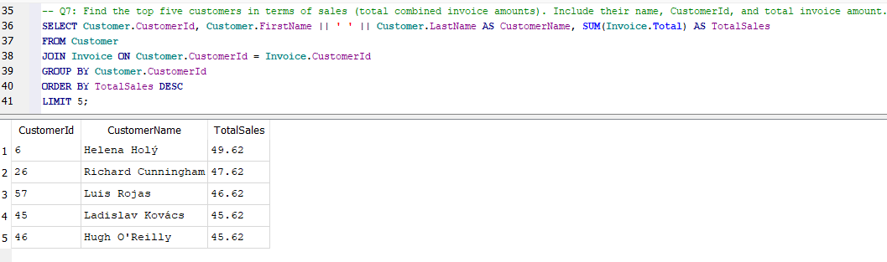

Q.8 Find out state wise count of customerID and list the names of states with count of customerID in decreasing order. Note:- do not include where states is null value.

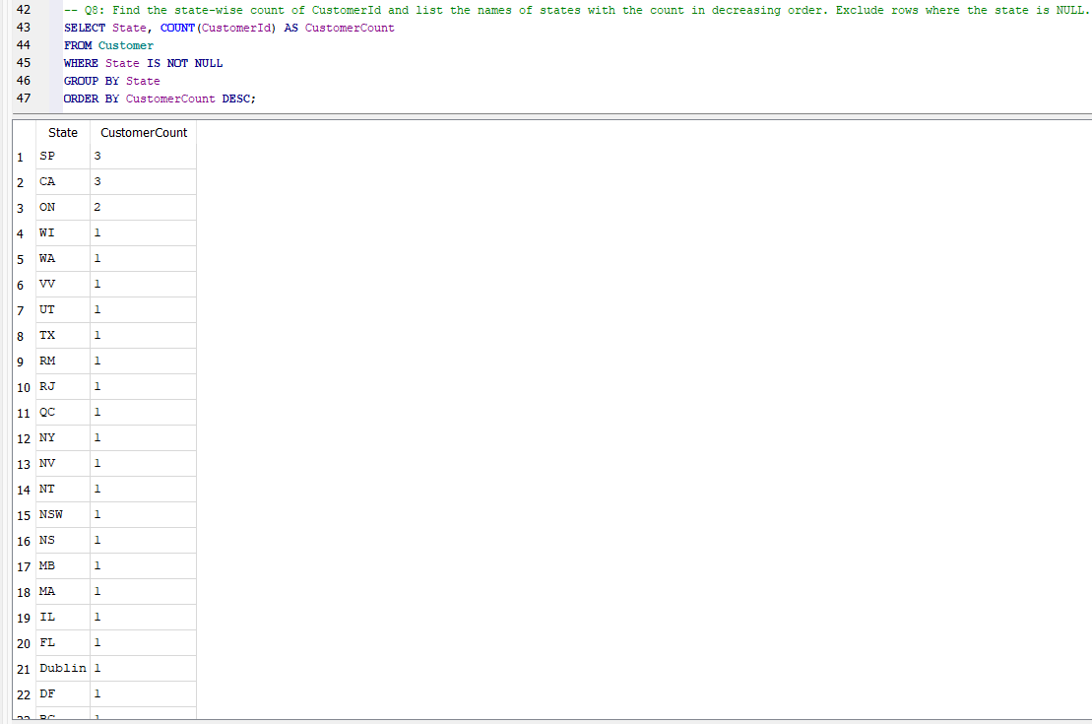

Q.9 How many Invoices were there in 2009 and 2011?

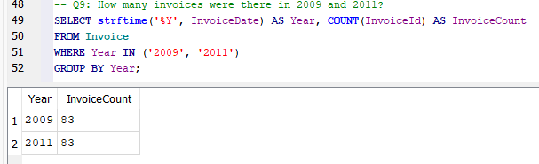

Q.10 Provide a query showing only the Employees who are Sales Agents.

